Suppose company A developed a gaming application, so to run this gaming application prerequisite are: -

1. Ubuntu 16
2. Tomcat 9
3. Java 1.7

Now many clients want to use the above game application, following are the system configuration of clients

|  |  |  |  |
| --- | --- | --- | --- |
| **Client Name** | **Ubuntu version** | **Tomcat version** | **Java version** |
| Client 1 | Ubuntu 14 | - | - |
| Client 2 | Centos | Tomcat 8 | - |
| Client 3 | Ubuntu 16 | Tomcat 9 | Java 1.7 |

Except client 3, no client has supported infra to run the above gaming application and client does not want to upgrade his infra. So how to handle the client who does not have proper infra and if he does not want to upgrade his infra.

We can overcome the above problem by providing VM or Container.

Both VM and container uses the concept of virtualization.

|  |  |
| --- | --- |
| **VM** | **Container** |
| Virtualization done on hardware level | Virtualization done on OS level, this is also called conterazitaion, Docker is the example of conterazitaion |

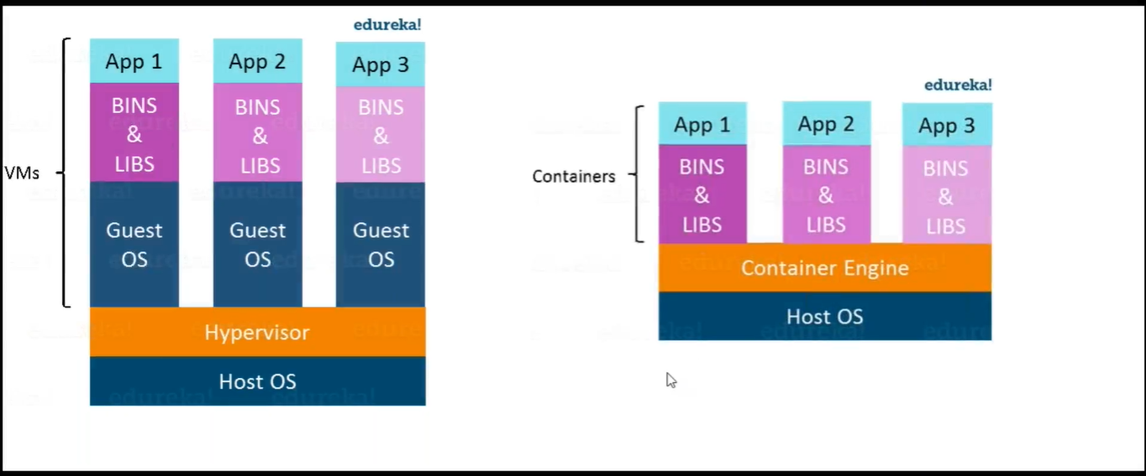

Host OS means our main operating system like windows10.

Hypervisor means virtual box in which we setup the Guest OS, using hypervisor we can allocate memory for Guest OS, we can manage Guest OS, Oracle VM VirtualBox is an example of Hypervisor.

Guest OS are ubuntu, Centos which we have configured inside Hypervisor.

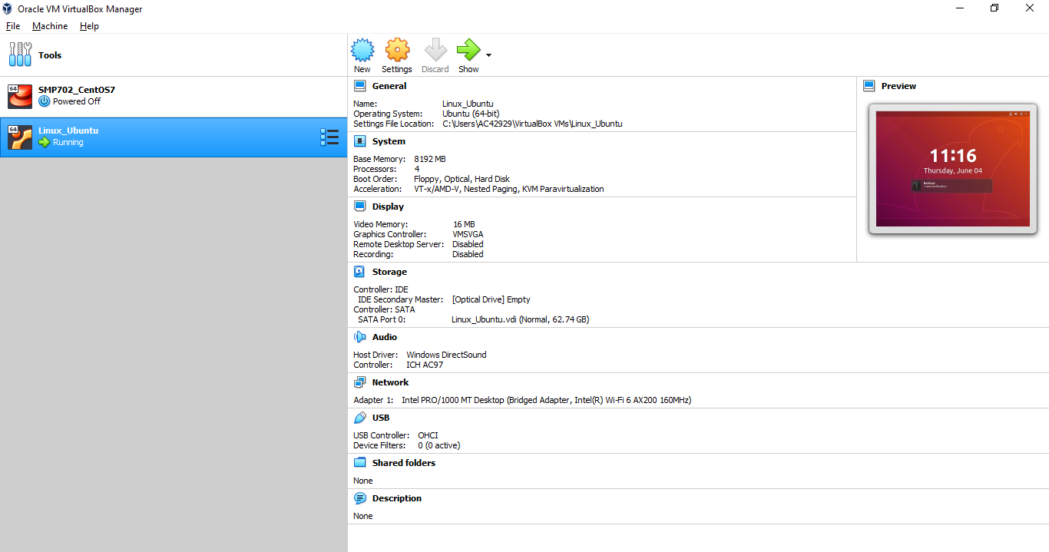

Note:- To work with VMs , we have to enable virtualization technique in BIOS. This means your hardware should support VMs.

Container Engine is the conterazitaion software. To run container, to work with container, we need conterazitaion software. Docker is the conterazitaion software.

Container will not have its own OS. Its run on top of container engine. It is light weight and works very fast. We can start the container on the fly automatically.

**Q1. Suppose we have window 10 as host OS, Container Engine is install on top of that, can we run another window, centos and ubuntu as container on top of Container Engine?**

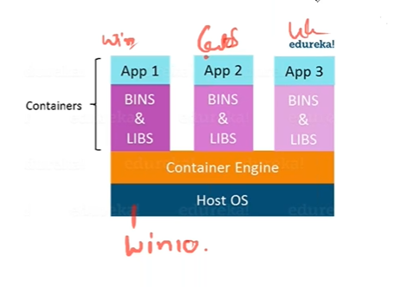

Ans :- centos and ubuntu are not possible because container will not have its own OS. It will share the OS of host. So windows container can share only windows host. But indirectly we can run centos and ubuntu on Windows host. See below architecture.

|  |  |
| --- | --- |
| Centos | ubuntu |
| Linux VM (install docker here) | |
| Host OS ( Windows 10) | |

**Problem faced by developer and tester :-**

1. An application works in developer’s laptop but not in testing or production. This is due to difference in computing environment between Dev, Test and Prod. Suppose we have to deploy a war file, so previously developers generate war file and give it to test and prod deployment. Developer has not aware of java versions, tomcat version in test and prod, so after deploying that war file, it may cause some error. Suppose developer has written code in Java 8, but in test and prod java6 is available so code will not run in test and prod because of java version mismatch.

To overcome this problem now developer wrap-up java, tomcat and war file inside a container. And ship the container.

|  |
| --- |
| War file |
| Java |
| Tomcat |

1. Applications are easier to build and maintain when broken down to smaller, composable pieces which work together (microservices). Each component is developed separately, and the application is the sum of its constituent.

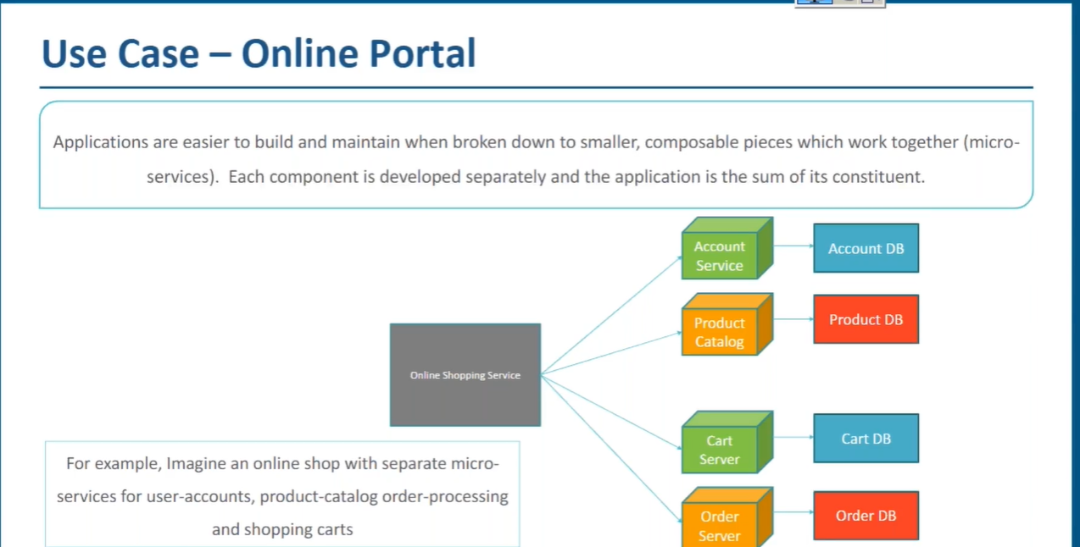

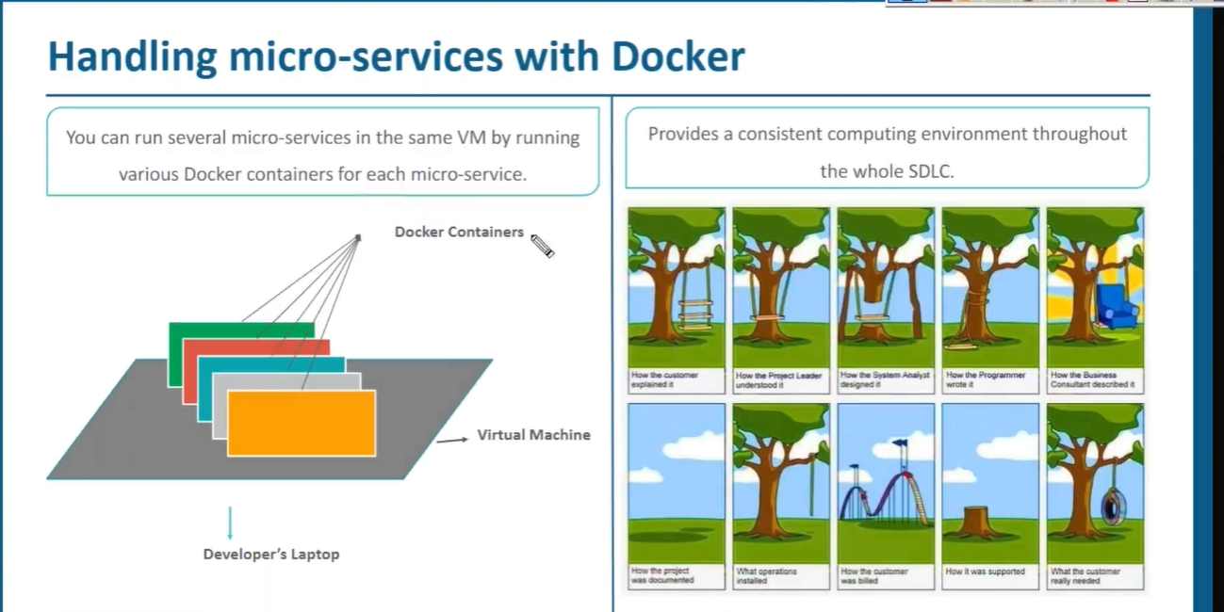

**Q2. What is Docker?**

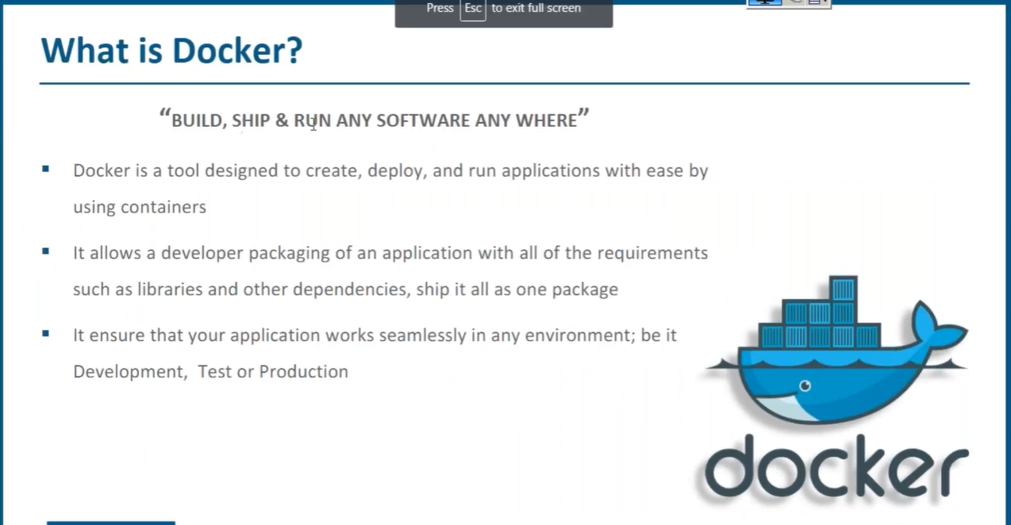

**Docker In A Nutshell :-**

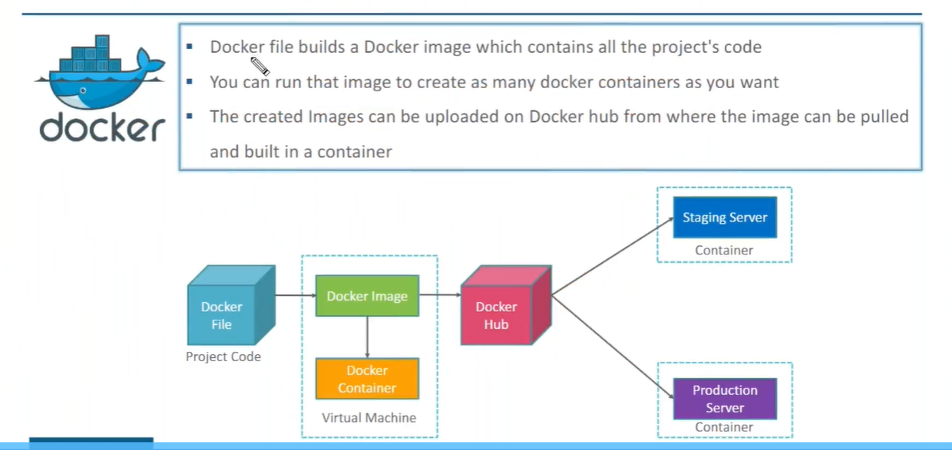

Note:- Running instance of image is called container.

**Q3. What is an image ?**

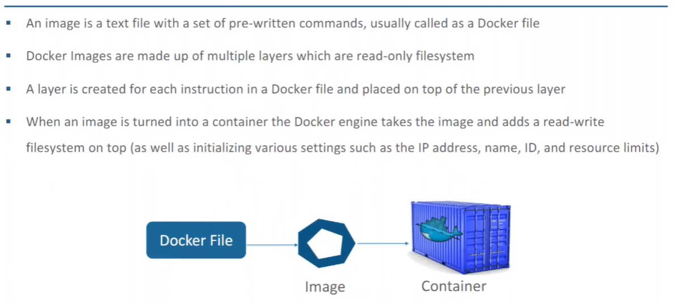

**Commands for docker :-**

1. To install docker :- **sudo apt-get install docker**
2. To start the docker :- **systemctl start docker**
3. To check the docker images :- **docker images**
4. To pull the image form docker hub :- **docker pull image_name** (i.e docker pull hello-world)
5. To pull the image form docker hub and run :- **docker run image_name** (i.e docker run hello-world)
6. To check the list of active containers :- **docker ps**
7. To check the list of all containers :- **docker ps -a**
8. To give the specific name to container :- **docker run --name container_name image_name** (i.e docker run --name mycontainer1 hello-world)
9. To search the images in docker hub :- **docker search image_name** (i.e docker search window)
10. To create the copy of image :- **docker tag old_image_name new_image_name**

(i.e docker tag docker.io/devopstrainer/myrepo1:v3.0 docker.io/devopstrainer/myrepo1:v4.0 )

1. To push the newly created image to dockerhub :- **docker push image_name** (i.e docker push docker.io/devopstrainer/myrepo1:v4.0 )
2. To push the file you need login credential :- **docker login**

**Understand how images are named :-**

Registry (It is the service where images are stored, i.e dockerhub)

Repository (Folder, collection of like images , ex :- centos)

Images (stored with tag, i.e centos6,centos7, centos5…)

Now suppose we want to access centos5, so how to access

If it is not official(not given by official docker ) :-

Registry/user_name (if not official)/ Repository:tag_name

Ex:- docker.io/devopstrainer/centos : 5

If it is official(given by official docker ) :-

Registry/ Repository:tag_name

Ex:- docker.io/hello-world

Note :- If you won’t specify tag_name then it will consider as latest

**Container Lifecycle / Running the container in different modes :-**

Till now we are running the container, but they are getting terminated immediately in next minutes. We need to keep the container up because some services might be running there, applications might be running there. So how to do that?

Execute this command :- **docker run -itd image_name** (ex :- docker run -itd ubuntu)

To stop the container :- **docker stop container_id** or **docker stop container_name** (ex:- docker stop a56afe6b2d2c)

itd means interactive terminal detached mode.

While using above command we will still be in host and we can run any number of container using above command.

Now, run in interactive terminal mode :-

**docker run -it image_name** (i.e docker run -it ubuntu)

While using above command we will get inside the container / shell of the container, we can do any specific configuration related to this particular container and we can run only one container using above command.

Using **exit** command you can get out of this and your container will be stopped.

I want to come out by still keep it up execute :- **ctrl+p, ctrl+q**

If you want to stop :- **docker stop container_id** or **docker stop container_name**

**Note :- docker run imge_name** command always create a new container while **docker start container_id** will start a exixting container

To get inside the container / shell of the container :- **docker attach container_id** (it won’t work if container is stopped. In such case first start the container and then execute this command)

To remove the container :- **docker rm container_id** (ex:- docker rm 7755d8e26913 86dbaac9ba80 1d7ad06f0934 80f9f13b8ac3 5520c41be658 482a52c9c4a9 3817b25dbbeb c3ae7adeb7f4)

To remove the images :- **docker rmi image_name** (ex :- docker rmi ubuntu hello-world)

**Docker Volumes :-**

To share the data from host to container or container to host , volumes comes into picture

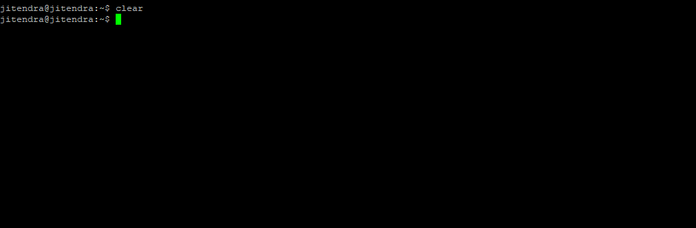

So here @jitendra is our host, many container(C1,C2,C3…Cn) running inside the host , container C1 contains log file , if in future any thing happen and due to this may be container will be down so we don’t want to loose the log file of C1 ,so we need the backup of log file from C1 to our host machine. And from host I want to put some files in C3.We can also share the data from container to containeter. Here volumes come into picture.

So to maintain persistent data of container we have volumes.

To check the docker volume :- **docker volume ls**

Volume is nothing but data directory in host.

To run the container with volume created :- **docker run -it --name some_container_name -v source_in_host:/destination_in_container image_name** (ex:- docker run -it --name test1 -v data:/voldir ubuntu)

test1 :- our own container name

v :-It is a flag, used to represent volume

data :-It is source, source menans what is the volume you want to map from host.

voldir :- It is destination, created under container and mapped with data inside host.

Go inside voldir and create some file , after creating file exit from container.

To inspect the volumes :- **docker volume inspect volume_name** (ex:- docker volume inspect data)

The above command will give the output like this,

[

{

"CreatedAt": "2020-06-06T15:15:03+05:30",

"Driver": "local",

"Labels": null,

"Mountpoint": "/var/lib/docker/volumes/data/_data",

"Name": "data",

"Options": null,

"Scope": "local"

}

]

In the above output Mountpoint is the location of volume data , using **cd /var/lib/docker/volumes/data/_data** command you can go inside this and verify the data.

Note :- We can attach same volume to multiple containers.

Bind Mounts:-

If you want to attach any other location other then volumes then it is called Bind Mounts.

**At the time of creating container I forgot to give the volume or mount the volume so how to handle that: -**

**docker run -it --name container_name ubuntu** (ex:- docker run -it --name testcopy ubuntu)

touch file1.txt

echo “Hi” > file1.txt

exit

I want to copy in tmp directory :- **cd /tmp**

Command to copy :- **docker cp container_name:/ file_name_which_to_be_copied** (ex :- docker cp testcopy:/ file1.txt)

ls

cat file1.txt

now file1.txt will be available under tmp directory.

**Suppose one file2.txt is there in tmp directory, I have to copy this to some container:-**

Go inside tmp directory

**docker cp file_name container_name:/destination_name** (ex :- docker cp file2.txt testcopy:/file2.txt)

**Creating the images in docker :-**

Images can be created in different ways

1. We can create the images from running container
2. We can create the images from docker file

**create the images from running container:-**

1. Run a container

**docker run -it --name new_container_name image_name (ex :- docker run -it --name forcommitcontainer ubuntu)**

add something inside this container:-

1. **apt-get update**
2. **apt-get install vim -y**

exit from the container by using **exit** command

1. Save the state of container as image

**docker commit container_name give_your_image_name** (ex:- docker commit forcommitcontainer devopstrainer/ubuntu)

1. Check the images

**docker images**

1. Run the newly created image

**docker run -it image_name:tag_name** (ex:- docker run -it devopstrainer/ubuntu:latest)

1. Check the previously added things, that should be available here

**vim**

**:wq!**

1. Check the file stack history of images

**docker history image_name:tag_name** (ex:- docker history devopstrainer/ubuntu:latest)

**create the images from docker file:-**

1. Create some directory

**cd /**

**mkdir directory_name** (ex:- mkdir dockerimages)

1. Go inside newly created directory

**cd directory_name** (ex:- cd dockerimages)

1. Create dockerfile here

**vim dockerfile**

**………………**

**//Below lines are called docker instructions**

**From base_image_name**

**Maintainer "maintainer_name" (i.e author name)**

**//Whaetver configuration you want , Whatever you want to execute during the creation of image, Whatever you want to install, write with run command**

**RUN apt-get update**

**RUN apt-get install vim -y**

**//If you want to execute a particular command when your contantainer is launched , write with CMD**

**CMD /bin/echo "Hello from me"**

Ex:-

From ubuntu

Maintainer "Jitendra"

RUN apt-get update

RUN apt-get install vim -y

CMD /bin/echo "Hello from me"

wq!

1. Build the docker file

**docker build -t some_image_name/repository_name:give_tag_name location_of_dockerfile** (ex:- docker build -t devopstrainer/ubuntu:dockerfile . )

1. You can run the container

**docker run -it some_image_name/repository_name:give_tag_name** (ex:- docker run -it devopstrainer/ubuntu:dockerfile)

sometimes above command will not enter into container shell, so execute

**docker run -it some_image_name/repository_name:give_tag_name /bin/bash** (ex:- docker run -it devopstrainer/ubuntu:dockerfile /bin/bash)

Some other docker instructions are:-

1. Expose
2. Add
3. Copy
4. Volume
5. ENV ENV_NAME “VALUE” (ex:- ENV JAVA_HOME “VALUE”)

**Port Forwarding :-**

1. Run some image

**docker run -itd tomcat**

1. get the ip of tomcat container

**docker inspect container_id** (ex:- docker inspect ca32b5d4691b)

Note:- inspect will show you the details of container in the form of json

1. **curl ip_of_container:port_in_which_container_running**

ex:- curl 172.17.0.3:8080

it will show html page, in this page somewhere you will find the success message.

1. Get the ip address of host

**ip addr show**

Note:- Container is in some other network and host is in some other network, so we can’t access services of container in host directly. This is for security reason.If we want to use any application from any container, expose the port of that container to host. But this is possible only if the image is build using **expose** command. When we inspect container we can see ExposedPorts in json.

1. Expose the port of container to host

**docker run -itd -P image_name (ex:- docker run -itd -P tomcat)**

Note:- this command will use random port of host, if you want to use your specific port of host, then

**docker run -itd -p your_specific_host_port:container_port image_name** (ex:- docker run -itd -p 9999:8080 tomcat )

This is called binding ports.

1. **docker ps**

you can check the random ports of host in which container port is forwarded.

1. In browser open, it will open application inside container

**ip_of_host:port_of_host_in_which_container_port_is_forwarded**

(ex:- 192.168.43.53: 32768)

1. If we want to expose while creating image using dockerfile

From ubuntu

Maintainer "Jitendra"

RUN apt-get update

RUN apt-get install vim -y

**EXPOSE 8080**

CMD /bin/echo "Hello from me"

How to convert a container into tar :-

**docker export container_id > some_name.tar** (ex:- docker export 9f4a0bb53404 > update.tar)

or

**docker export container_name > some_name.tar**

How to get the image from tar :-

**docker import - some_image_name < name_of_tar_file.tar** (ex:- docker import - mytarimage < update.tar )

How to convert a image into tar :-

**docker save -o some_name.tar image_name:tag_name** (ex:- docker save -o update3.tar devopstrainer/ubuntu:dockerfile)

from this tar if you want to get images :-

**docker load < tar_name.tar** (ex:- docker load < update3.tar )

**Publish to private registry :-**

1. Pull the registry

**docker pull registry:2**

1. Run the above registry image to start the registry service

**docker run -itd -p 5000:5000 registry:2**

1. Check if registry service is up or not

**curl -i** [**http://localhost:5000/v2/**](http://localhost:5000/v2/)

1. now, I want to push some images to this registry.

**docker tag old_image_name new_image_name** (ex:- docker tag ubuntu localhost:5000/ubuntu:v1.0)

**docker push image_name** (ex:- docker push localhost:5000/ubuntu:v1.0 )

1. To check the catalog:-

**curl -i** [**http://localhost:5000/v2/_catalog**](http://localhost:5000/v2/_catalog)

Note:- your image name should be prefixed with registry address.

**Docker Echo System With Networking**

**………………………………………………………………………………………………………**

Docker is mainly supported by Linux OS, now window 10 also support docker. Mac and older version of windows will not support docker, so we use Docker Toolbox inside mac and older version of windows to support docker. Docker Toolbox also provides Linux environment for Docker.

Docker Toolbox contains following things :-

1. Docker Machine for running docker-machine command
2. Docker Engine for running docker command
3. Docker Compose for running the docker-compose commands
4. Kitematic – Desktop GUI for Docker
5. A shell preconfigured for a Docker command-line environment

Download and install docker Toolbox.

After installing you will see three icons on desktop

1. Docker QuickStart Terminal 2. Oracle VM VirtualBox 3. Kitematic(Alpha)

Open Docker QuickStart Terminal, if you open Oracle VM VirtualBox , it shows default vm is running.

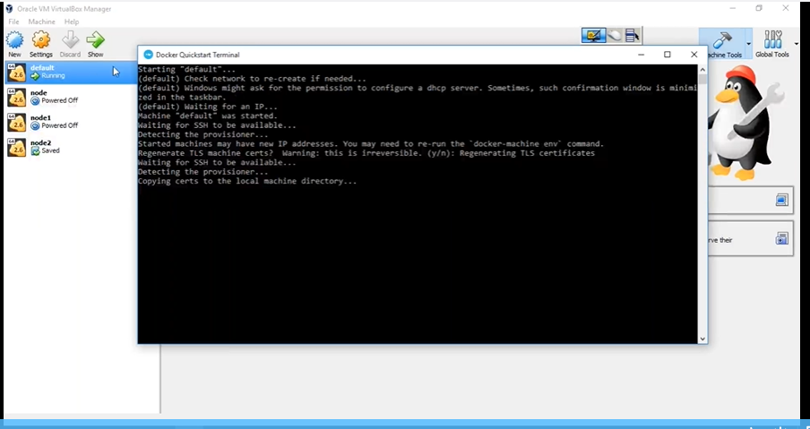

**Docker Machine :-**

Docker Machine is a tool which can manage/spin any number of docker host (vm/server where docker is running)

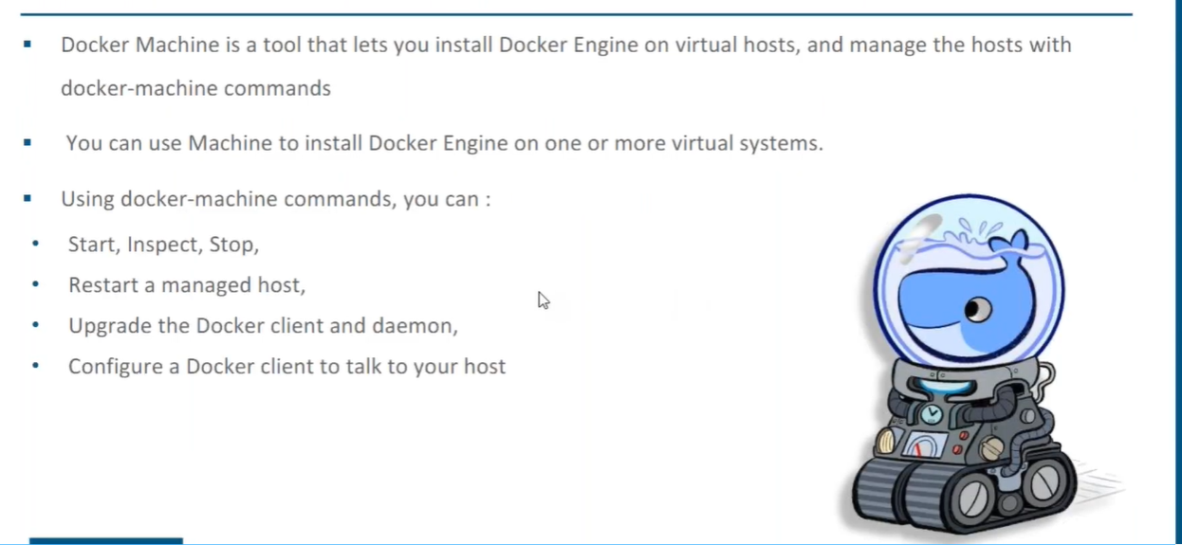

**docker-machine create --driver vitrualbox some_node_name** (ex:- docker-machine create --driver vitrualbox node3 )

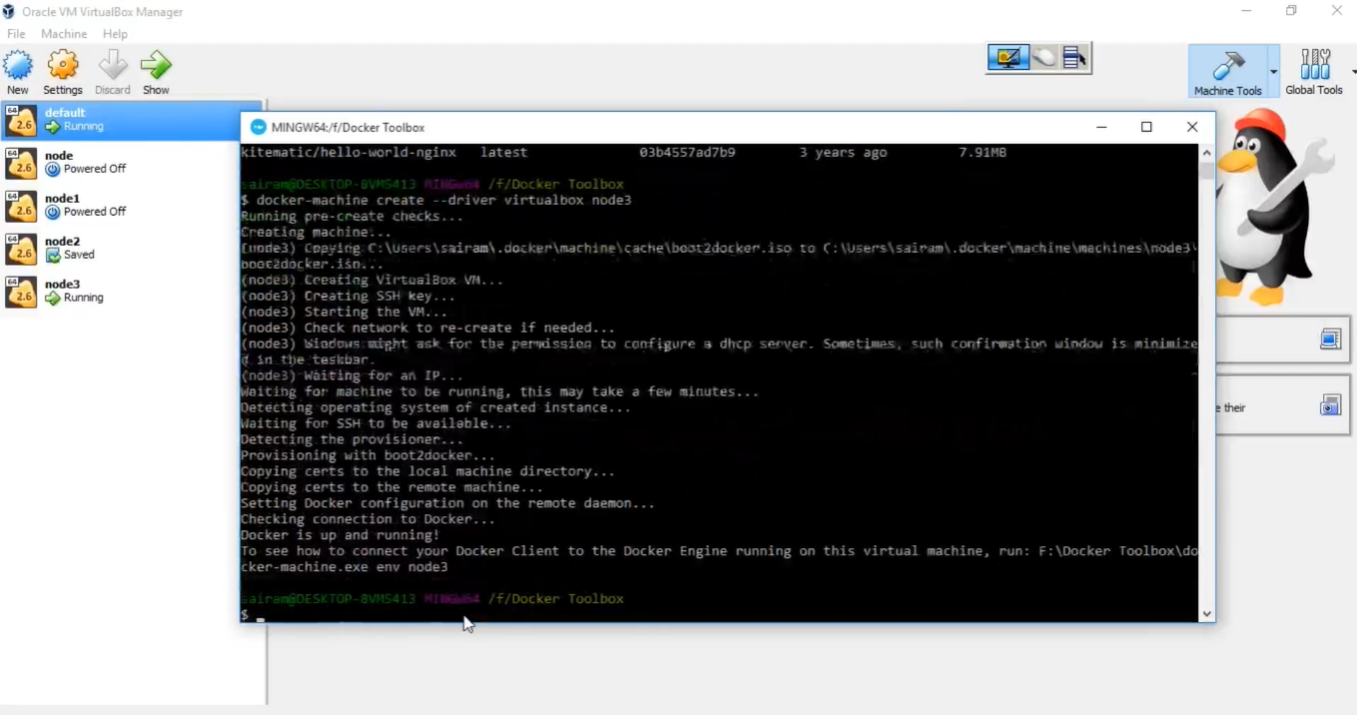

It has created node3 docker host. The default Linux operating system is boot2docker

To see the list of docker host :- **docker-machine ls**

If you want to go into particular host :- **eval “$(docker-machine env node_name)”** (ex:- eval “$(docker-machine env node3)” )

Now you can execute docker command as usual :-

**docker ps**

**docker ps -a**

**docker run -itd -p 8000:80 nginx**

**docker images**

**docker-machine ip node3**

**curl ip_of_node3:8000**

Note :- We can install docker tool box on Linux also.

**Docker Engine:-**

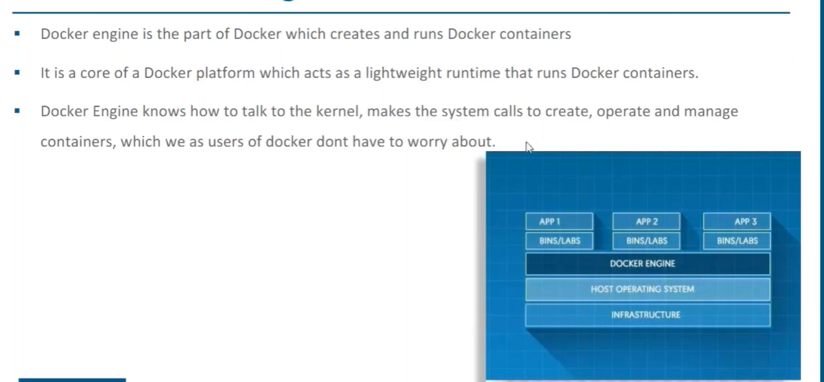

**Docker Compose :-**

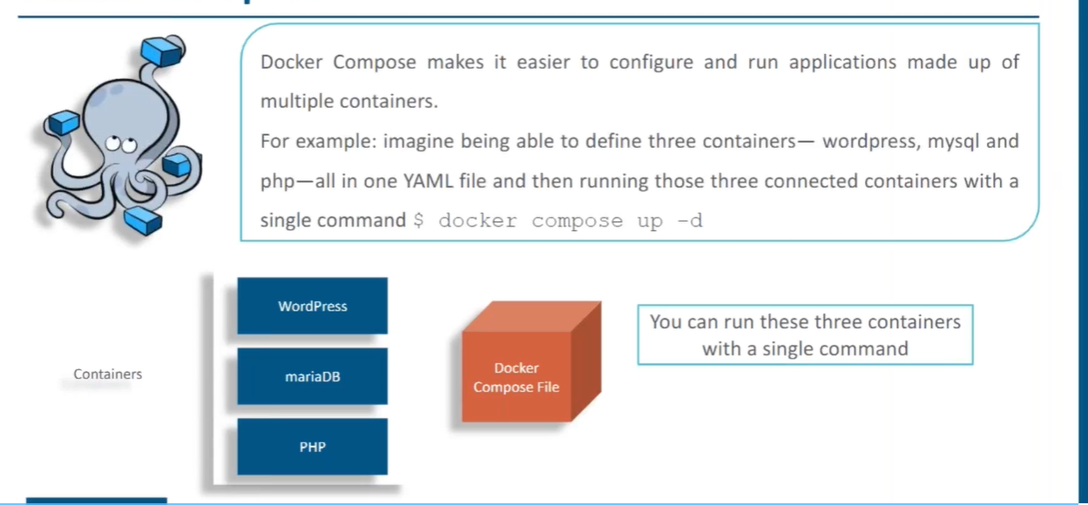

**sudo apt-get install python-pip**

**pip install docker-compose**

**pip install --upgrade pip**

delete previous images and all containers

**mkdir dockercompose**

**cd dockercompose**

**vim docker-compose.yml**

…………………………..

wordpress:

image: wordpress

links:

- wordpress_db:mysql

ports:

- "7070:80"

wordpress_db:

image: mariadb

environment:

MYSQL_ROOT_PASSWORD: edureka

phpadmin:

image: corbinu/docker-phpmyadmin

links:

- wordpress_db:mysql

ports:

- "8181:80"

environment:

MYSQL_USERNAME: root

MYSQL_ROOT_PASSWORD: edureka

**:wq!**

**docker-compose up -d**

It will download the mariadb ,wordpress, and corbinu/docker-phpmyadmin. First it will start mariadb, wordpress, and corbinu/docker-phpmyadmin

Containers are :- wordpress,wordpress_db,phpadmin

links set some dependency between the containers i.e I want wordpress services to be communicating with wordpress_db container

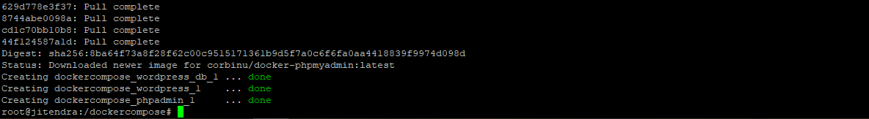

We can check all three containers are running:- **docker ps**

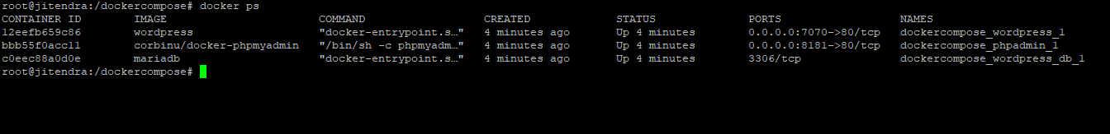

get the port of the host :- **ip addr show**

**ip_address:port**

<http://192.168.43.194:7070/> -> Here wordpress should be running

<http://192.168.43.194:8181/> -> Here php should be running

if you want to stop all the above container together and also it will remove them :- **docker-compose down**

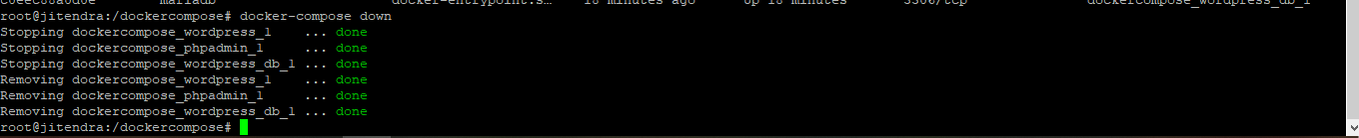

To stop the service :- **docker-compose stop**

To start the service :- **docker-compose start**

If you want to delete all this related to service except volume and image :- **docker-compose down**

**Kitematic :-**

Kitematic provides gui for docker. This is for window and mac system. You get it along with tool box.

**Deploying a war-file inside container:-**

Now we have war file which we have created through Jenkins job. So how we will deploy this war file inside docker container.

First create an image through docker file. Write a docker file in which copy this war file to webapps directory of tomcat.

Steps:-

1. Create a Jenkins job :- DeployContainer
2. Inside build section choose Execute shell and write the below shell script

**rm -rf dockerimages**

**mkdir dockerimages**

**cd dockerimages**

**cp /var/lib/jenkins/workspace/Package/target/addressbook.war .**

**touch dockerfile**

**cat <<EOT>> dockerfile**

**From tomcat**

**ADD addressbook.war /usr/local/tomcat/webapps**

**CMD "catalina.sh" "run"**

**EXPOSE 8080**

**EOT**

**docker build -t devopstrainer/ubuntu:$BUILD_NUMBER .**

**docker run -itd --name=mycontainer-$BUILD_NUMBER -P devopstrainer/ubuntu:$BUILD_NUMBER**

1. Its get deployed, you can check below url

<http://192.168.43.30:32769/addressbook/>

**Docker Network and Docker Swarm**

**………………………………………………………………………………...**

There are three types of network available by default in docker.

1. Bridge network :-

Ip Network

Docker host machine

Ip Network

Container 3

Container 2

Container 1

Docker host machine on which docker is installed. We have container inside docker. Usually host has some ip network and containers has also some ip network. Both the network is different. Containers are running into the private isolated networks for security concerns. This means any thing inside container is not exposed to the host. If we want to access anything from container, we need to do port forwarding. Whenever you run the container by default all go to bridge. Every container is assigned with some ip address and all the networks, this is all taken care by docker ethernet adapter docker0. This is installed by default when we install docker.

1. Host network:-

Same Ip network

Docker host machine

Container 1

Container 2

Here host and the container will be in same network. This means all thing inside container is exposed to host. So there is no security.

1. None network: -

Here we cannot see network interface at all.

Command to check the network :- **docker network ls**

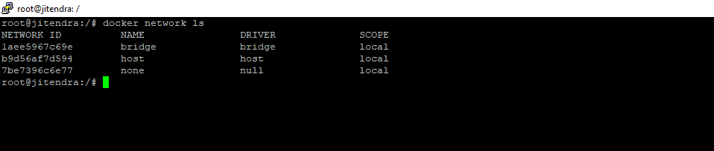

Command to inspect the network :- **docker network inspect network_name** (ex:- docker network inspect bridge)

**Docker Swarm:-**

Docker Swarm is a tool which can mange multiple containers running on cluster of nodes or group of nodes ( i.e cluster of docker host / group of docker host )

Host 3(Worker)

Host 2(Worker)

Host 1( Manager)

100 container

100 container

100 container

How to manage above 300 containers. Managing of container means high availability of services, autoload balancing of containers, scaling them, rolling updates, rollbacks. We cannot do this manually so there comes clustering tool Swarm. It is also called as Container orchestration tool or clustering tool. It can manage a bunch of containers running on a cluster (group of nodes / host machines).

There can be any number of nodes, but one node will act as manager. Manger node will take care of all the task like high availability of services, autoload balancing of containers, scaling them, rolling updates, rollbacks. Other node act as worker node which run the container, off course manager will also run the container but manager mainly used to schedule the work.

To act a machine as a manager, run this command :- **docker swarm init --advertise-addr ip_of_machine_which_you want_to_act_as_manager**

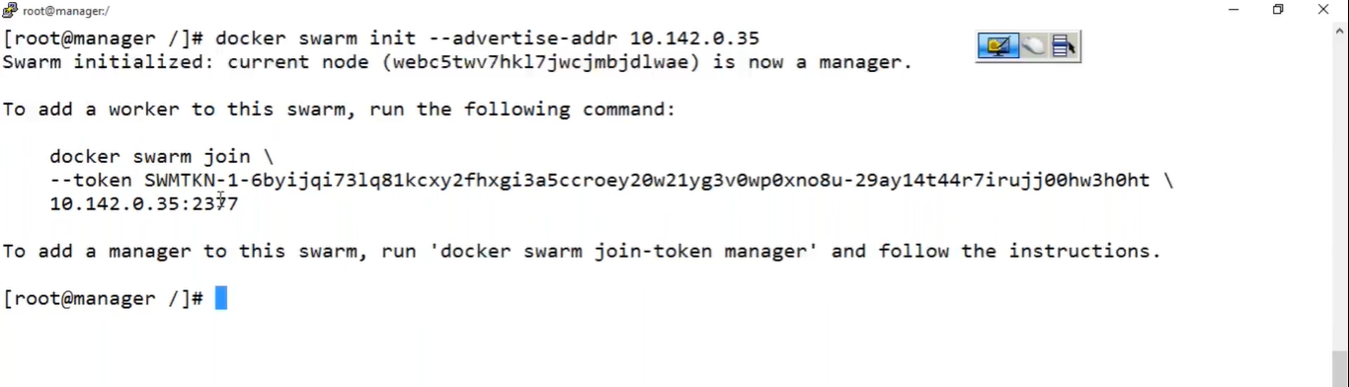

Above command generated a token, copy the token and run on the other machine which will act as worker node.



To check the nodes linked to manger execute this command :- **docker node ls**



After executing above token on worker machine if you check **docker node ls** on manager then it will show like below screen

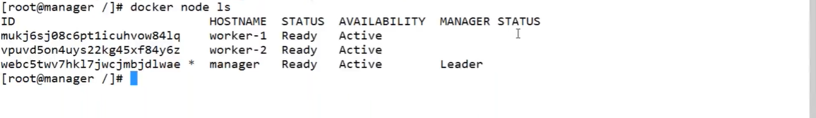

If you want to add more manager to cluster, execute this command on previous manager/ main manager :- **docker swarm join-token manager**

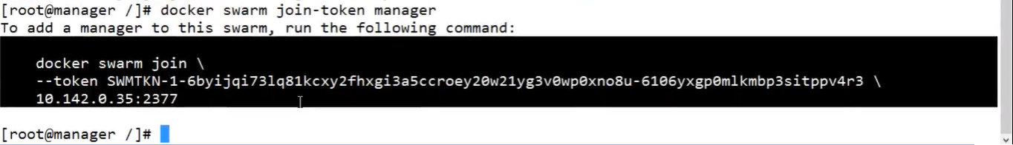

Above command generated a token, copy the token and run on the other machine which will act as manager node.

Similarly at any time if you want to add another working node execute this command :-

**docker swarm join-token worker**

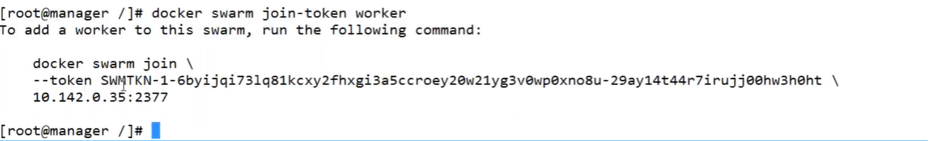

Above command generated a token, copy the token and run on the other machine which will act as worker node.

Whenever you start containers in cluster , you refer the containers as services. You call the container as service. So to command to start a service :- **docker service create -p 80:80 --name some_service_name image_name**

Note:- I have run the above command on manager

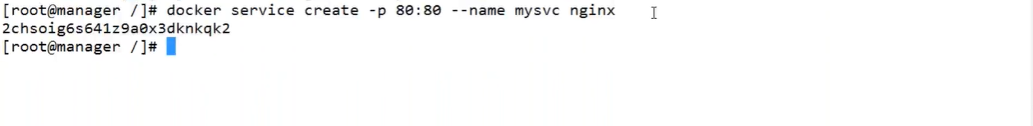

To check the service :- **docker service ls**

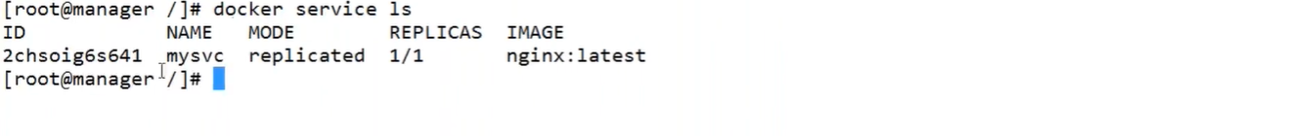

**Where the above service is running?**

In cluster its not important to bother where it is running. Only we should think about whether it is running or not, because it could be running on anywhere in the cluster.

If you want to check where it’s running, execute this command :- **docker service ps service_name**

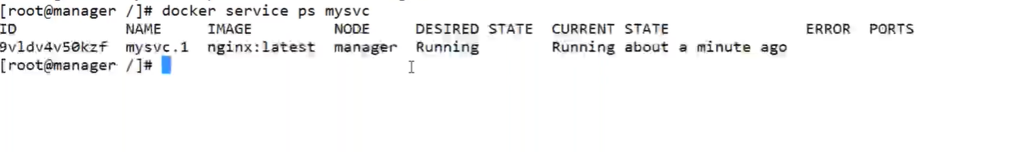

If you hit any node with its ip and port of service. It will show you the service. That is the beauty of cluster. **192.168.43.30:80**

**How to put manager off to taking the loads?**

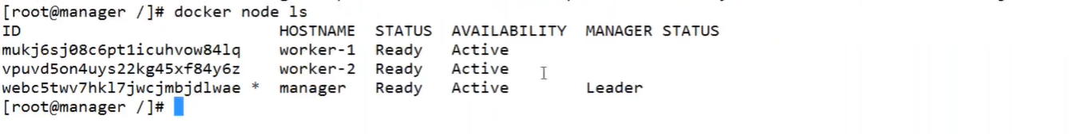

In above picture you can see, availability of manager is showing as active. I want to put availability off.

**docker node update --availability drain manager_name**

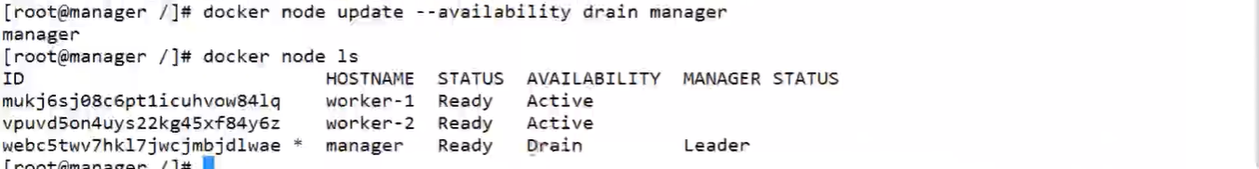

In this case we are keeping machine in drain state, we are not putting off. So it won’t impact the services, it’s still running. But service is transferred form manager node to other worker node.



We can still see the services by hitting any node.

Suppose by chance worker-1 node also went to drain state, but then also our services will not be down, it will be transferred to other worker node. This is called high availability of services.

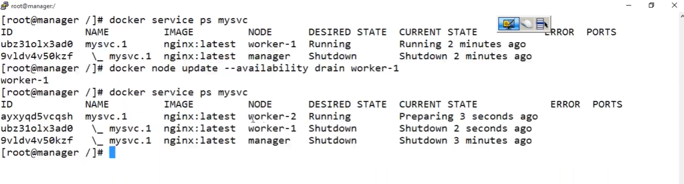

How to scale up a service :-

Suppose we want to scale to 10

**docker service scale service_name=number**

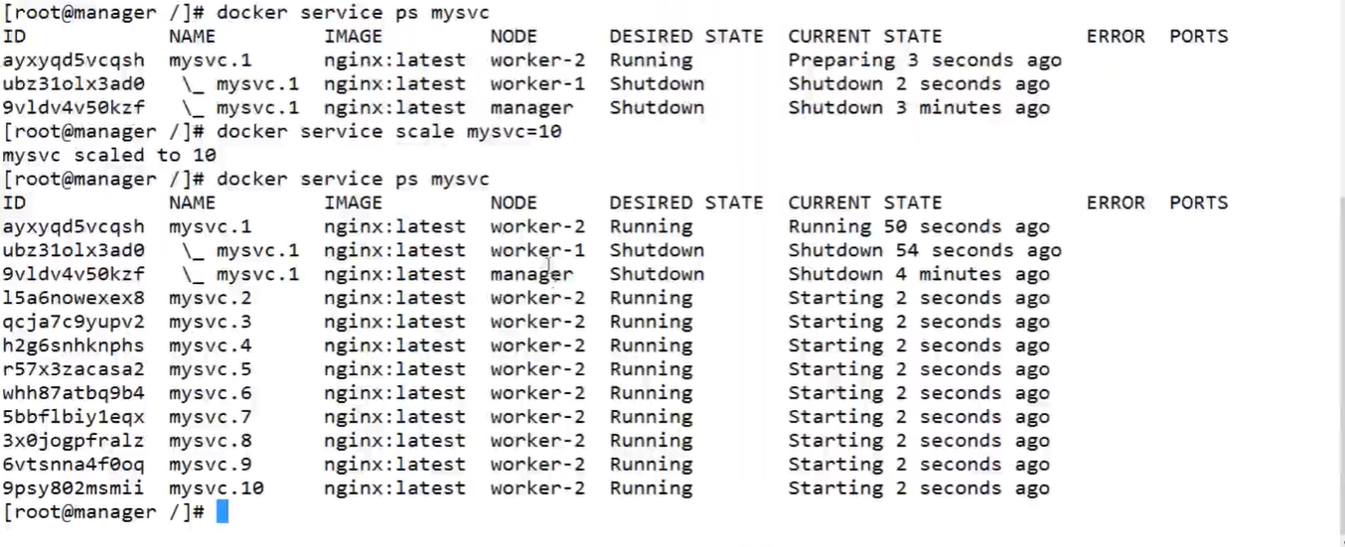

**How to make manager active from drain state?**

**docker node update --availability active manager_name**

**How to make worker node active from drain state?**

**docker node update --availability active worker_node_name**



Now, let us say we want to scale more, let us 20

**docker service scale mysvc=20**

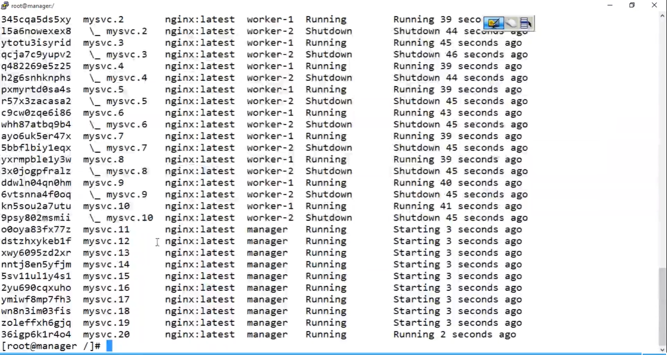

Now 10 services are running on manager and 10 services on worker-1. So this is called auto load balancing.

Features for Swarm cluster : -

1. High availability
2. Auto load balancing
3. Scaling up / Scaling down

Through Swarm we can do Rolling updates and Rollbacks.

Whenever you run containers in Swarm , you will get two more networks created.

1. docker_gwbridge
2. ingress

**docker network ls**

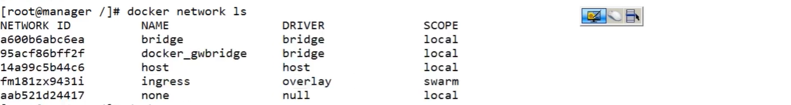

**Why the above two network used by swarm?**

By default all your containers get attached to ingress overlay.

If you will inspect any container you will get ingress details.

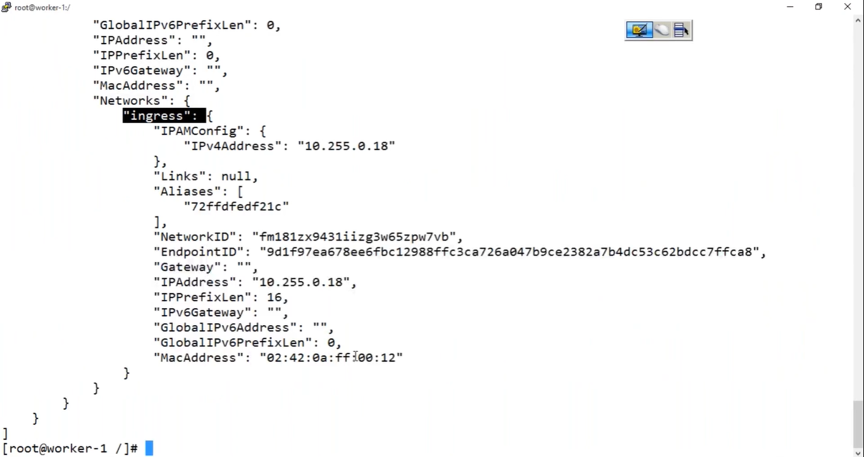

**Ingress (overlay) network**

docker_gwbridge

Host specific network

Host specific network

Host specific network

Contains container in swarm mode

Contains container in swarm mode

Contains container in swarm mode

Manager

Worker-2

Worker-1

Ingress (overlay) network works on top of host specific network. It allows to communicate between the container running on different host.

Suppose we have 300 containers, it is not a good practice to attach all 300 containers to Ingress.

So create your own ingress network. Decide which container should you attach to newly created ingress network.

To remove a service :- **docker service rm service_name**

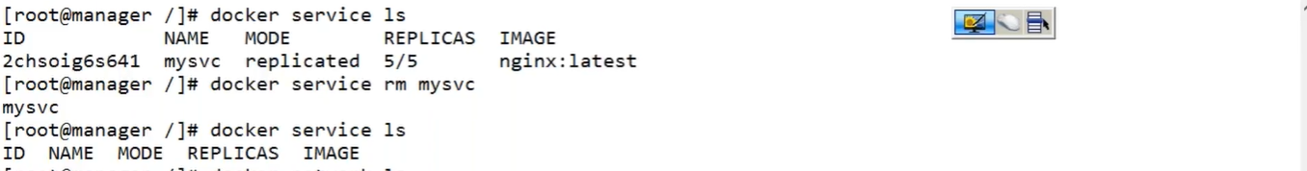

Create our own network :-

**docker network create -d overlay some_network_name**

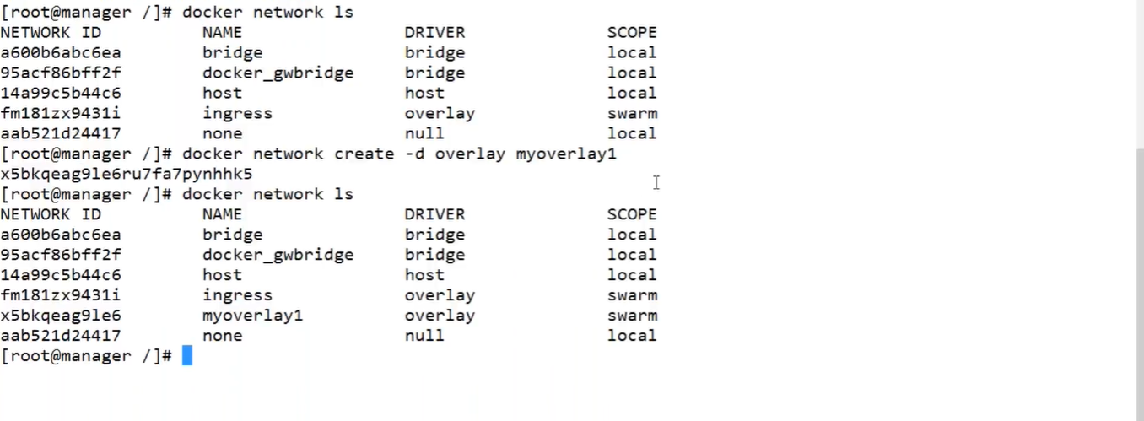

Create the service and attach to network :- **docker service create --name service_name --network network_name -p host_post:container_port image_name**

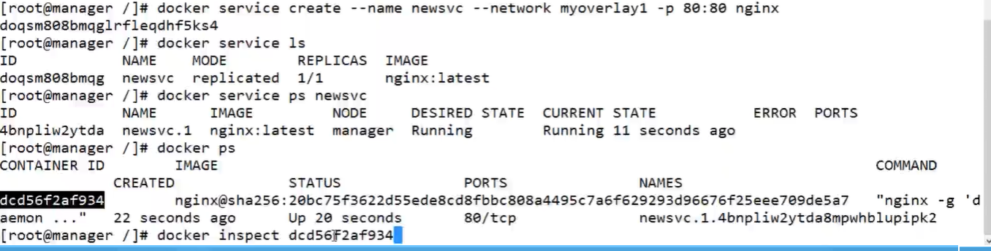

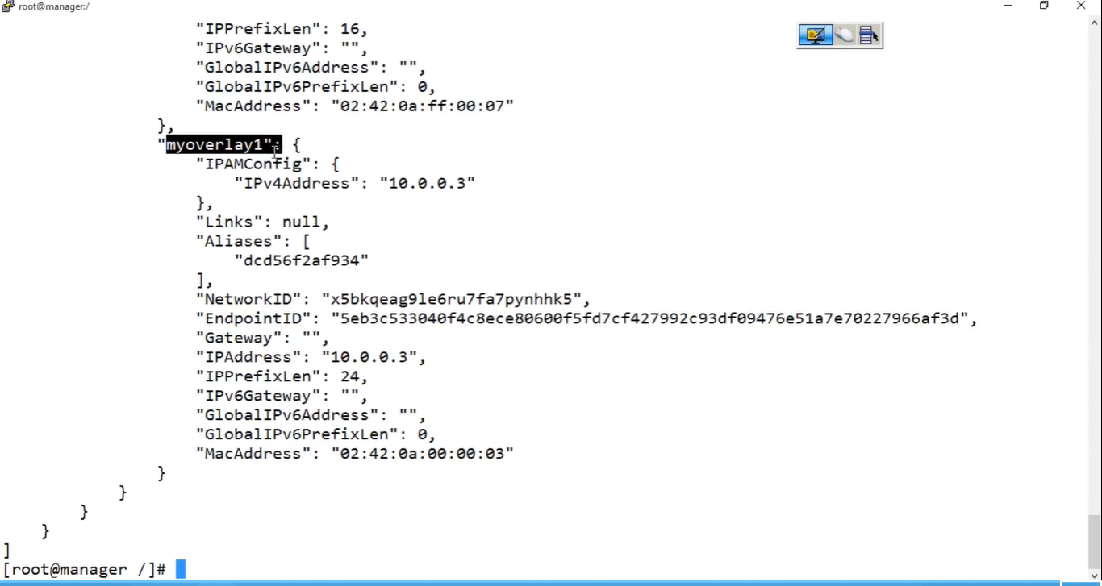

**Configuration Management Tool Puppet:-**

1. Suppose we have very small number of infrastructure, let’s 5 servers . On all server we want to install some packages, let’s http. So I can login to each server and do it manually. Imagine we have 500 servers and we have to install some packages on each server. If we install the packages on each server manually , time consuming will be more, more people required, chance of getting error is high because we do the things manually. So there comes configuration management tool which can automate the configuration of huge infrastructure. One such tool is Puppet.
2. Let’s suppose we have different environment, say test environment and prod environment.

In both environment we need java 1.7 , I have installed java 1.7 both the places manually. After some times our application is working fine in test environment but not working in dev environment. We can overcome this by using configuration management tool. It will check the configuration regularly. So if any error occur in configuration, the tool will automatically resolve the error. So we can say configuration management tool pool regularly. So we can achieve consistency across the environment.

1. Suppose your current infrastructure is 100 and tomorrow you are going to scale them up to 1000 . Even though you are scaling to huge infrastructure, so configuration management tool have good control over them.

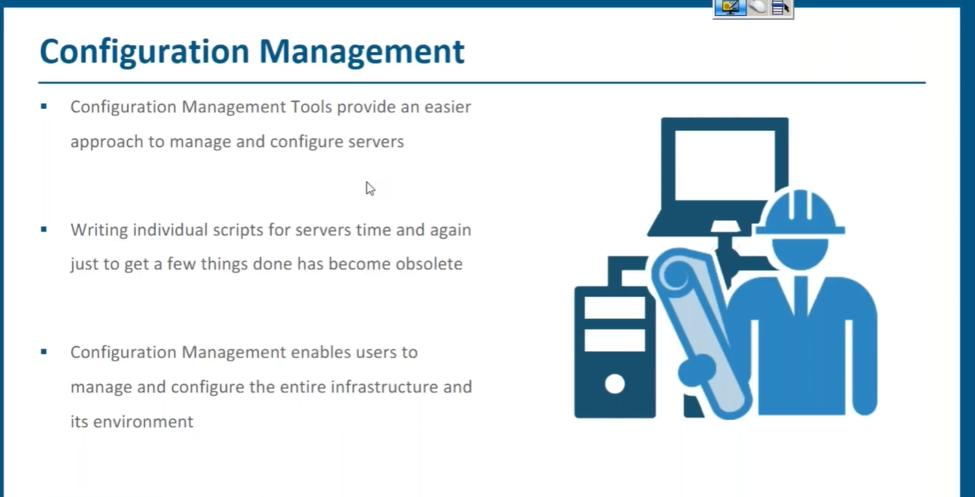

**Infrastructure as code :-** Writing code for operations or setting up the infra is called Infrastructure as code.

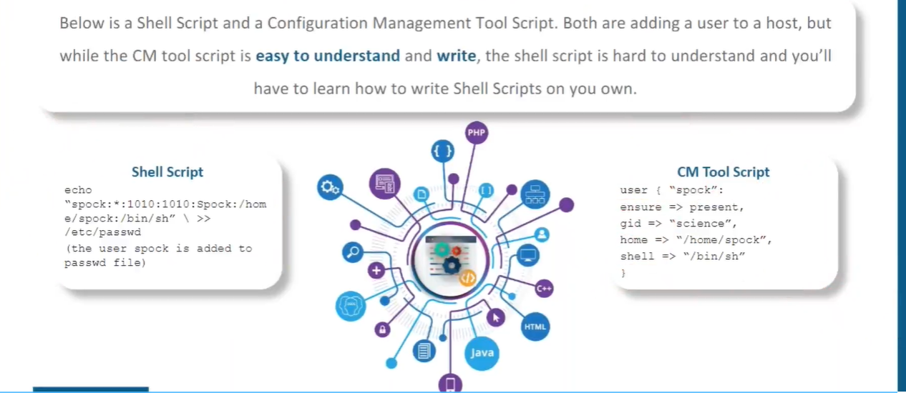

**Puppet :-**

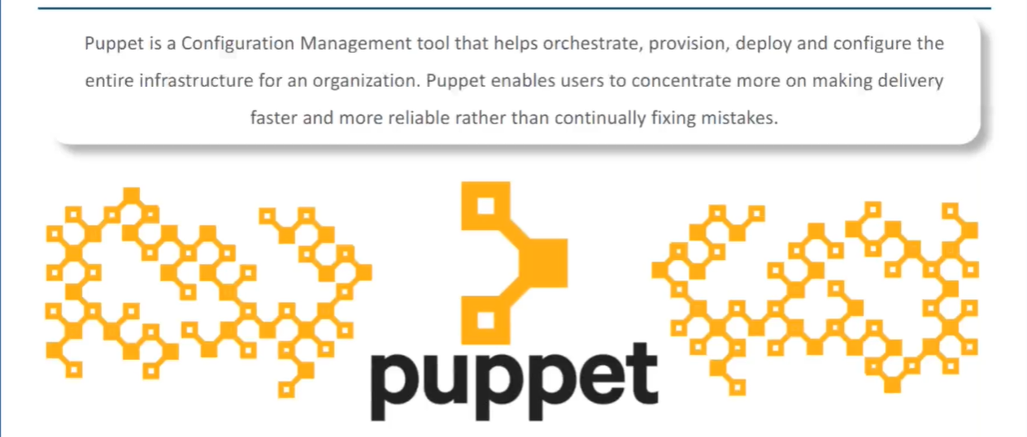

Puppet works on master-slave architecture. On one machine we should install puppet master and all other server we should install puppet agent. After that we have to connect the agent with master. Once it gets connected, agents will download the configuration from master. Puppet uses pull configuration i.e its pull the configuration from master.

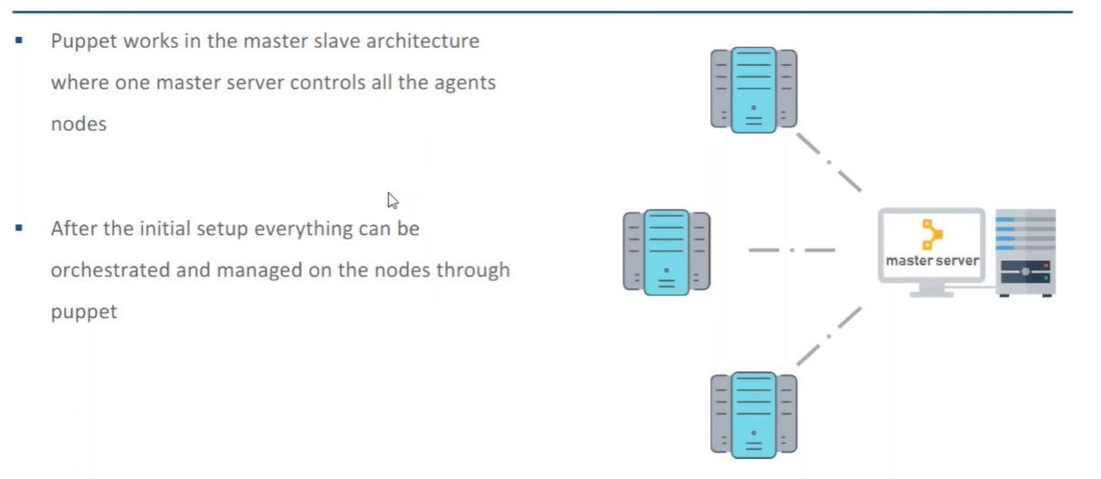

Puppet code is written in puppet DSL ( puppet domain specific language).

Puppet architecture:-

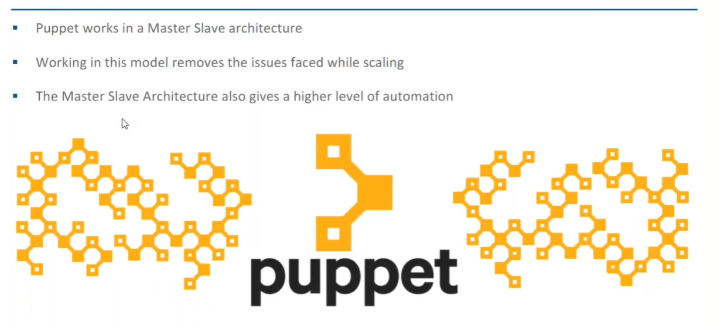

Puppet master is must be Linux, puppet agent can be anything (Linux, Windows…etc).

Master and agent connect via SSL through port 8140

Puppet is basically a Ruby application, this does not mean that we have to write puppet code in Ruby.

We write puppet code in puppet DSL.

Steps :-

1. Agent sends facts to the master. Facts means details of agent (cpu,memory...etc). It sends facts as node object.
2. After getting the facts, master identify the node.
3. Master compile the catalog (catalog is the document which will have all the configuration to be done on agent). On master machine Catalog is created by using puppet code and facts.
4. Once catalog is ready, agent will pull the catalog and apply the catalog.

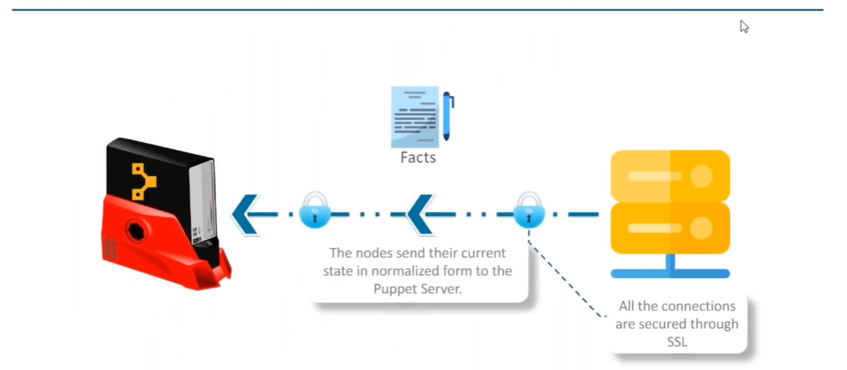

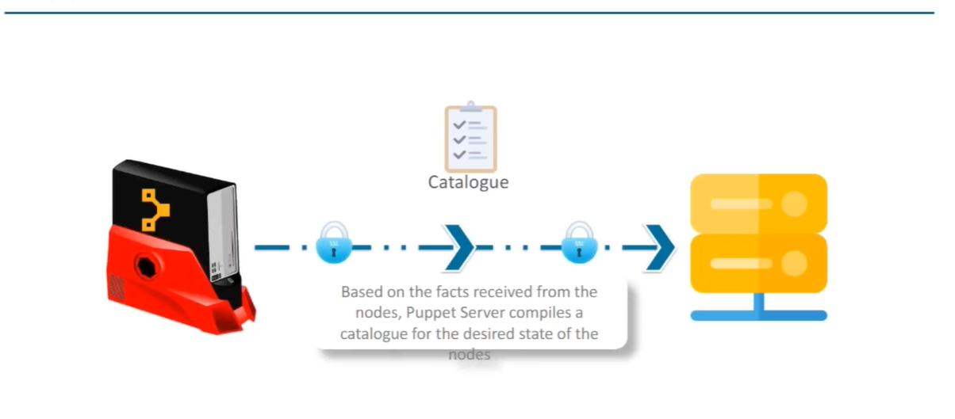

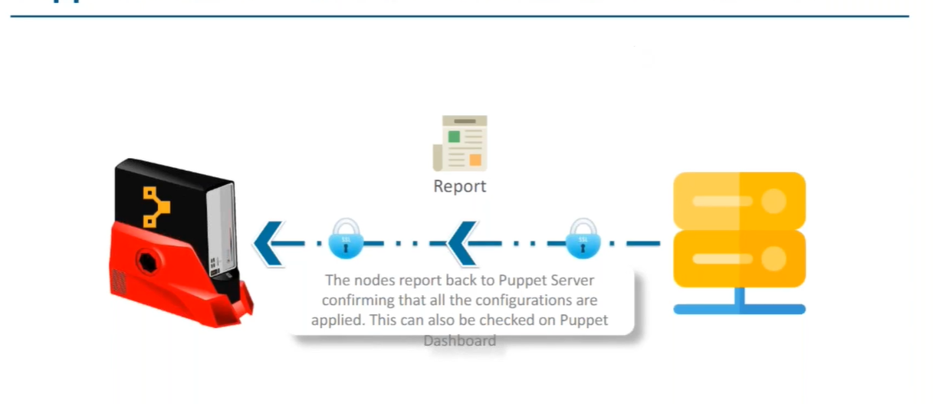

Catalog Compilation :-

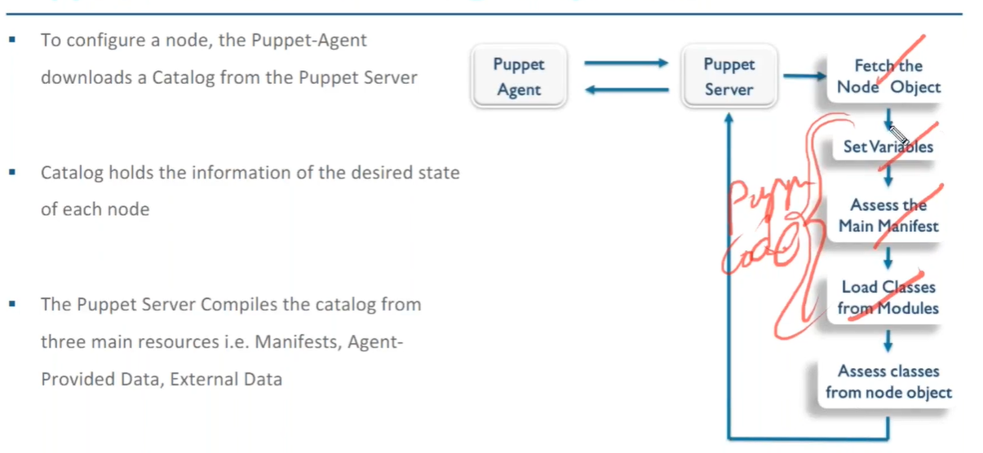

Installing puppet :-

1. On master machine :-

**vim /etc/hosts**

add the ip of master and slave here

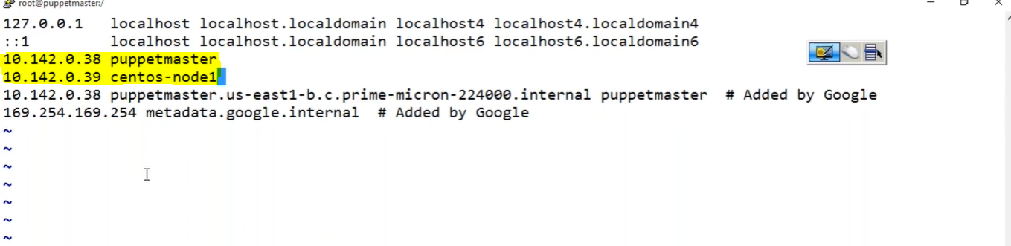

1. Do the above steps on slave machine also.

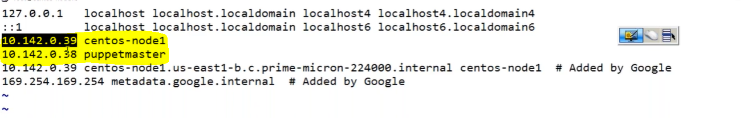

1. To check whether connection is established or not, execute below command on slave

**ping puppetmaster**

1. To check whether connection is established or not, execute below command on master

**ping centos-node1**

1. Install puppet server on master

Download the puppet package using :-

**wget https://apt.puppetlabs.com/puppetlabs-release-pc1-xenial.deb**

After downloading the package install it using dpkg with -i flag :-

**dpkg -i puppetlabs-release-pc1-xenial.deb**

update all packages

**sudo apt-get update**

Install puppet server

**sudo apt-get install puppetserver**

<https://www.bogotobogo.com/DevOps/Puppet/Puppet6-Install-on-Ubuntu18.0.4.php>

1. Install puppet on slave

Download the puppet package using :-

**wget https://apt.puppetlabs.com/puppetlabs-release-pc1-xenial.deb**

After downloading the package install it using dpkg with -i flag :-

**dpkg -i puppetlabs-release-pc1-xenial.deb**

update all packages

**sudo apt-get update**

Install puppet server

**sudo apt-get install puppet-agent**